Development of MambuRide Online Booking System for Mamburao Grand Terminal

A Project Proposal

Presented to

the Faculty of College of Arts, Sciences, and Technology

by:

Bernardo, EL Lorenz T.
Bas, Jirah Camille P.
Grapani, Jeniffer

October 2025

Table of Contents

INTRODUCTION 2
1.1. Overview of the Current State of the Technology 5
1.2. Project Rationale 8
PROJECT DESCRIPTION 10
2.1. Problem Statement 10
2.2. Proposed Research Project 11
2.2.1. General Objectives 12
2.2.2. Scope and Limitations 13
2.2.3. Flowchart/Hierarchy Chart of the Project 14

INTRODUCTION
The way the world handles public transportation is quickly changing, with more and more reliance on digital systems and the internet (Kato & Chalermpong, 2024). The development of the MambuRide Online Booking System for the Mamburao Grand Terminal is part of this necessary worldwide trend. Our main goal is to create a digital system that makes bus travel in Mamburao, Occidental Mindoro run more smoothly and gives customers a better, more modern experience (Nexi Group, 2024). By moving away from paper tickets and old methods, this project will help reduce costs for operators and simplify the entire process for passengers, which also supports environmental goals by reducing waste (Openvia, 2024).

This system is urgently needed because the terminal currently relies on old-fashioned, manual ways of working. These paper-based systems are often slow and lack clear oversight, which can lead to long waiting times and opportunities for mistakes or financial corruption (Terminal cargo clearing official, 2018). Today's travelers expect services to be clear and easy, much like they experience with popular booking apps, where they can see prices and track their trips in real-time (Delos Santos, 2021).

The project is built on proven technology and successful examples from within the Philippines. MambuRide is essentially a form of Transportation Management System (TMS), which is a computer tool that manages the moving of people (Oracle, 2025). The success of bus apps like MovOn, the first mobile app in the Philippines to allow users to book guaranteed bus seats, shows this idea is workable. Developers for MovOn solved difficult challenges like letting customers pick their exact seat and preventing errors when multiple people book at once (AllRide Apps, 2025). MambuRide will use these successful, tested solutions to provide a reliable reservation and parcel delivery service for the Mamburao area.

This system is very important for the local growth of Mamburao. The local government has invested money to build better roads to increase business and improve life in rural areas (DPWH, 2024). Local studies in Mamburao have shown that while small businesses are moving to digital tools like online payments, many people still struggle with poor internet access and a lack of digital skills (Tayamaan Research Team, 2024). Therefore, MambuRide must be designed to work easily even with low internet speed, and training must be provided to ensure that the entire community can use this technology and benefit from an improved local economy.

1.1. Overview of the Current State of the Technology

The MambuRide Online Booking System, like similar transport tools in the Philippines, uses modern digital technology. Its main parts are a mobile phone application for passengers and drivers, plus a central website or web system that links everything together. This setup lets people book their rides without standing in line at the Mamburao Grand Terminal. The system works because it is connected to the internet, allowing it to move information quickly between the user's phone and the main computer. (Alfred & Kaijage, 2020)

A major goal of using this technology is to make travel easier and more reliable for passengers. The system allows users to secure a guaranteed seat for their ticket. This focus on easy, fast service shows that people are ready to use these digital tools for their transport needs because they are easy to use and understand. (Gagap & Beduya, 2020)

This system is part of a bigger effort in the country to modernize public transportation. By letting passengers book for tickets ahead of time, the MambuRide system helps reduce the number of people waiting at the terminal, especially during busy seasons. This method is seen as a simple way to improve how the terminal runs and gives passengers peace of mind before they even start their trip. (Arrogancia, 2024)

1.2. Project Rationale
The MambuRide Online Booking System for the Mamburao Grand Terminal is being created to make booking public transport trips much easier and better. Right now, people often have to wait in line, and they don't know for sure if a seat is available or when the trip will actually leave. This causes long waits and makes passengers unhappy. The goal of MambuRide is to fix this by offering a simple online platform to view schedules and reserve a seat from anywhere. By making this initial step digital, we are moving away from manual, paper-based methods, which is key for a modern terminal. This system is designed only for booking seats and will not handle any payments, making it simple to build and use quickly.

The main benefit of MambuRide is that it gives passengers better control and transparency over their travel plans. They can quickly see what trips are available and secure their seat, which dramatically cuts down on waiting time and confusion at the terminal. For the terminal staff and transport companies, the system acts as a central hub for knowing exactly how many seats are booked for each trip in real-time. This allows them to manage vehicles and schedules more effectively to meet passenger demand, helping to reduce overcrowding and ensure trips run smoothly. By using technology to connect passengers and operators directly, MambuRide brings order and predictability to the terminal’s daily operations, offering a crucial upgrade to public service.

PROJECT DESCRIPTION

2.1. Problem Statement
The Mamburao Grand Terminal currently faces a significant issue with its passenger boarding and trip management process: the lack of real-time, easily accessible booking information. Without a central system, passengers intending to travel often arrive at the terminal with no certainty about seat availability on their desired trip. This forces them to wait in lines, leading to potential frustration, confusion, and sometimes missing a trip entirely because a vehicle fills up unexpectedly.

Furthermore, the existing manual methods for tracking booked seats make it hard for terminal staff and transport operators to get an accurate, up-to-the-minute count of passengers. This lack of clear data leads to inefficient planning, making it difficult to decide if an extra trip is needed or if a departure needs to be adjusted. The manual approach also creates the risk of overbooking or underutilization of seats. To solve these problems and create a smoother, more reliable travel experience, a web-based system is needed. This system must allow passengers to quickly reserve their seats online and give operators a clear, digital view of all current bookings for all upcoming trips.

2.2. Proposed Research Project
This research project, titled "Development of MambuRide Online Booking System for Mamburao Grand Terminal," proposes the creation of a reliable, real-time platform focused purely on passenger seat reservation and trip management for public utility vehicles at the terminal.

The primary objective of the "Development of MambuRide Online Booking System for Mamburao Grand Terminal" proposed project is to address the following key questions:
- What specific improvements can the proposed booking system deliver to address the challenges of queueing and uncertainty in public transport travel at the terminal?
- Who will be the primary beneficiaries of this system's implementation, and how will it improve their experience (passengers, operators, and terminal management)?
- What specific features and functionalities will the MambuRide system offer to enable passengers to easily reserve seats and allow operators to manage bookings without handling payments?

2.2.1. General Objectives
1. To develop a comprehensive online booking system for the Mamburao Grand Terminal, encompassing the following key aspects:
1.1. To develop an effective methodology for creating the system, ensuring its successful implementation.
1.2. To define the system's core capabilities, including the ability to
a. Allow passengers to view real-time trip schedules and available seats.
b. Facilitate online reservation and issuance of a digital booking confirmation (ticket).
- To create a user-friendly and reliable online presence (website/application interface) for MambuRide, making it easy for the commuting public to access the booking service.
- To conduct thorough testing to ensure the functionality and reliability of the developed system, guaranteeing a seamless user experience and optimal performance for both passengers and terminal operators

2.2.2. Scope and Limitations
The "Development of MambuRide Online Booking System for Mamburao Grand Terminal" project is focused strictly on the process of seat reservation and trip information management. The core scope is to provide a user-friendly, real-time platform where passengers can view available schedules for public utility vehicles and reserve a seat. For terminal operators, the system will offer a digital dashboard to track and manage these reservations instantly, aiding in better fleet deployment and passenger control. The resulting output will be a valid reservation voucher that the passenger will use to exchange for a physical ticket and pay the fare at the terminal, as MambuRide will not be processing any financial payments directly from the passenger.

However, the system has clear limitations. Its effectiveness depends on consistent internet connectivity for both passengers making the booking and operators receiving the updates at the terminal. While the system provides real-time data, minor delays in synchronization between the central database and operator display may occasionally occur. Crucially, MambuRide's role is strictly that of a booking agent; it is not responsible for the actual transport service, including the condition of the vehicles, the conduct of the operator's staff, on-time departures, or any personal injury or loss of property during the journey. The success of the reservation process also relies on the accuracy of the trip schedules provided by the van/bus operators themselves and the passenger's ability to use the digital platform. Furthermore, the system does not cover ticket payment processing, which remains a mandatory manual step at the terminal.

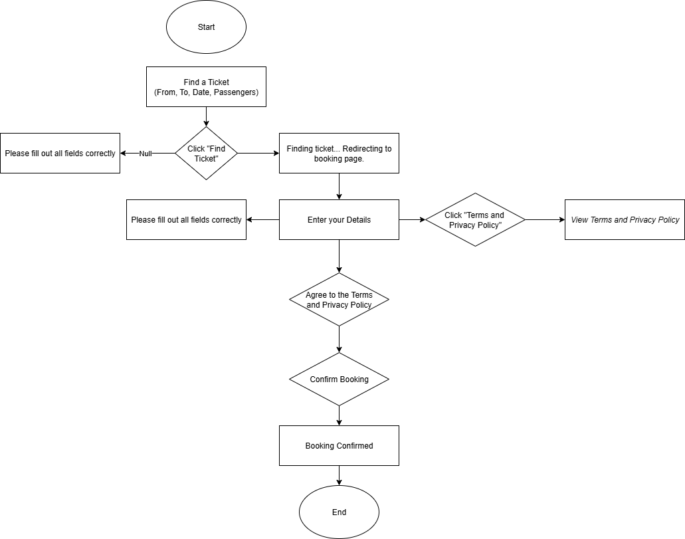
2.2.3. Flowchart/Hierarchy Chart of the Project

References

AllRide Apps. (2025). MoveOn - Philippines' first bus app | bus booking... - AllRide Apps [Case study]. https://www.allrideapps.com/case-studies/movon/
Department of Public Works and Highways (DPWH). (2024, July 24). DPWH reports infrastructure achievements at Post-SONA discussions. https://www.dpwh.gov.ph/dpwh/news/34724
Kato, H., & Chalermpong, S. (2024). Digital transport platforms and urban mobility: Ride-hailing applications in Southeast Asia. Routledge.
Nexi Group. (2024, July 1). The role of digital payments in public transport: a game changer. Nexi Group. https://www.nexigroup.com/en/media-relations/news/2024/07/digital-payments-public-transportation/
Openvia. (2024). Advantages of smart ticketing for transportation users. https://www.openvia.io/advantages-of-smart-ticketing-for-transportation-users/
Oracle. (2025). What is a transportation management system (TMS)? https://www.oracle.com/scm/logistics/transportation-management/what-is-transportation-management-system/
Tayamaan Research Team. (2024). Impact of digital transformation on small businesses in Purok 1, Barangay Tayamaan, Mamburao, Occidental Mindoro (Research document III-FINAL-041224). Scribd. https://www.scribd.com/document/834835278/III-FINAL-041224
Alfred, J., & Kaijage, S. (2020). Integrated Android mobile application and web-based system for bus rapid transit system. International Journal of Scientific Research in Science, Engineering and Technology, 7(1), 11-17.
https://scispace.com/pdf/design-of-an-integrated-android-mobile-application-and-web-4isxfml0xs.pdf
Arrogancia, R. U. (2024, December 22). Online systems for buses sought. BusinessWorld Online.
https://www.bworldonline.com/the-nation/2024/12/22/643044/online-systems-for-buses-sought/
Gagap, R. A., Jr., & Beduya, D. S. (2020). Mobile bus ticketing system: Development and adoption. International Journal of Advanced Trends in Computer Science and Engineering, 9(1.3), 189-196.
https://www.researchgate.net/publication/342875059_Mobile_Bus_Ticketing_System_Development_and_Adoption

